Name: Class: Date:

THE EAR – STRUCTURE AND FUNCTION

Introduction
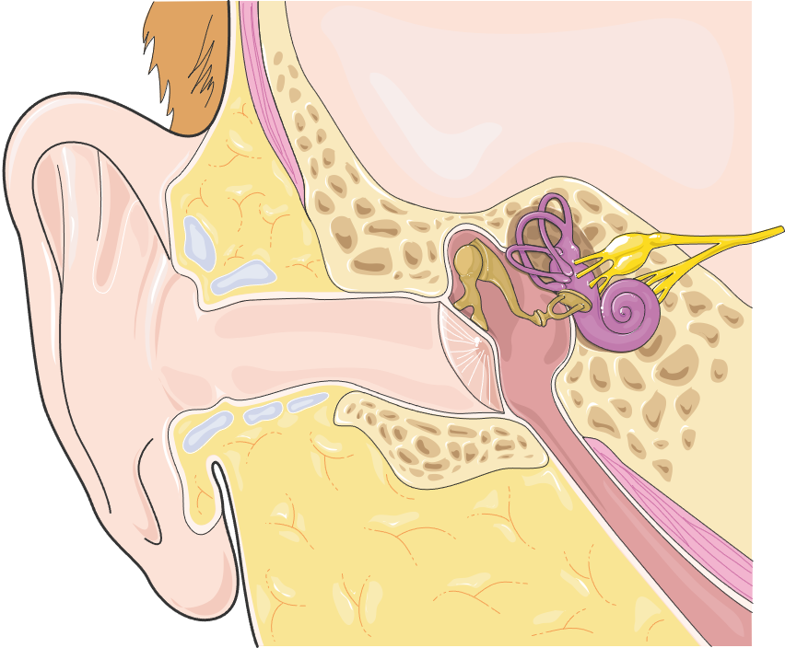
The ear is the body’s sense organ for hearing. It gathers sound waves from the environment and transmits them to sensory receptor cells found within cochlea of the inner ear. The vibrations are converted into nerve impulses, which are carried by the auditory nerve to the brain where they are interpreted by the auditory cortex as sound.
image

Internal Anatomy of the Ear

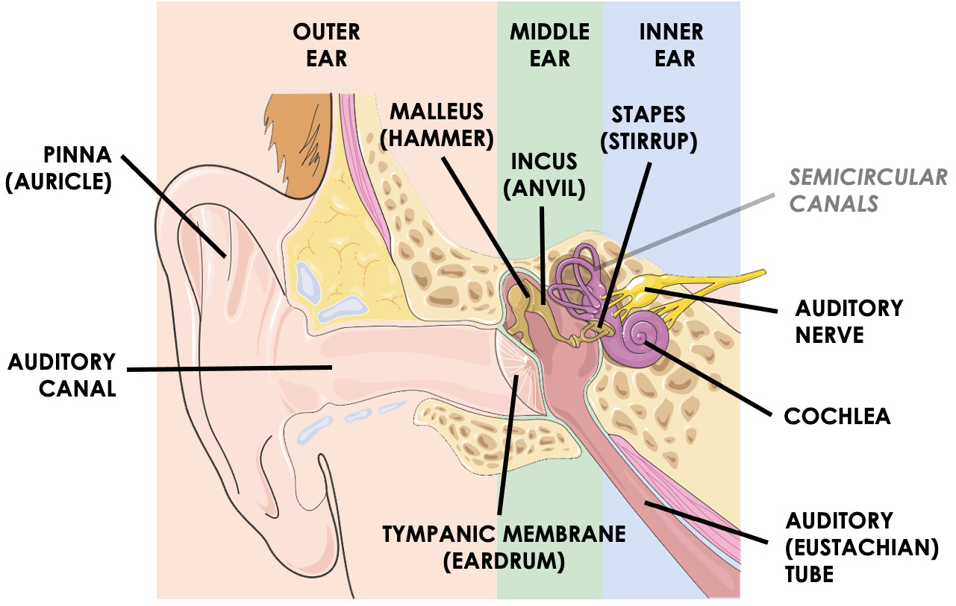
Anatomically, the ear is divided into three areas: the outer ear, middle ear, and inner ear. The outer ear is made up of the pinna, auditory canal, and tympanic membrane. The pinna (also called the auricle) is a shell-shaped structure that directs sound waves into the auditory canal. The auditory canal is a narrow, long tube that transmits sound into the middle ear. The canal is lined with ceruminous glands that secrete a waxy, yellow substance called cerumen (ear wax) that traps debris from the external environment. At the proximal end of the canal is the tympanic membrane or eardrum, which separates the outer ear and middle ear and transmits sound waves to the middle ear through mechanical vibrations.
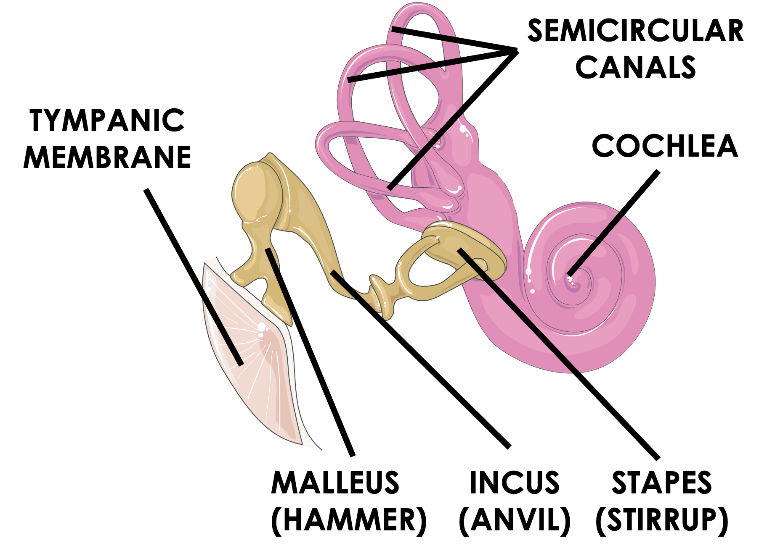
The middle ear is a small space called the tympanic cavity within the temporal bone of the skull that houses the three smallest bones in the body: the auditory ossicles. The ossicles are named for the Latin words that describe their shape: malleus (hammer), incus (anvil), and stapes (stirrup). The main job of the ossicles is to convert compression waves from the vibrating eardrum into pressure waves within the fluid of the inner ear. The tympanic cavity is connected to the throat (pharynx) via a long slender tube called the auditory tube or Eustachian tube. This tube helps equalize air pressure on both sides of the eardrum.

The inner ear consists of a large snail-shaped structure called the cochlea as well as three, fluid-filled semicircular canals that play an important role in the body’s sense of equilibrium. The cochlea contains a specialized fluid called perilymph, through which pressure waves travel.
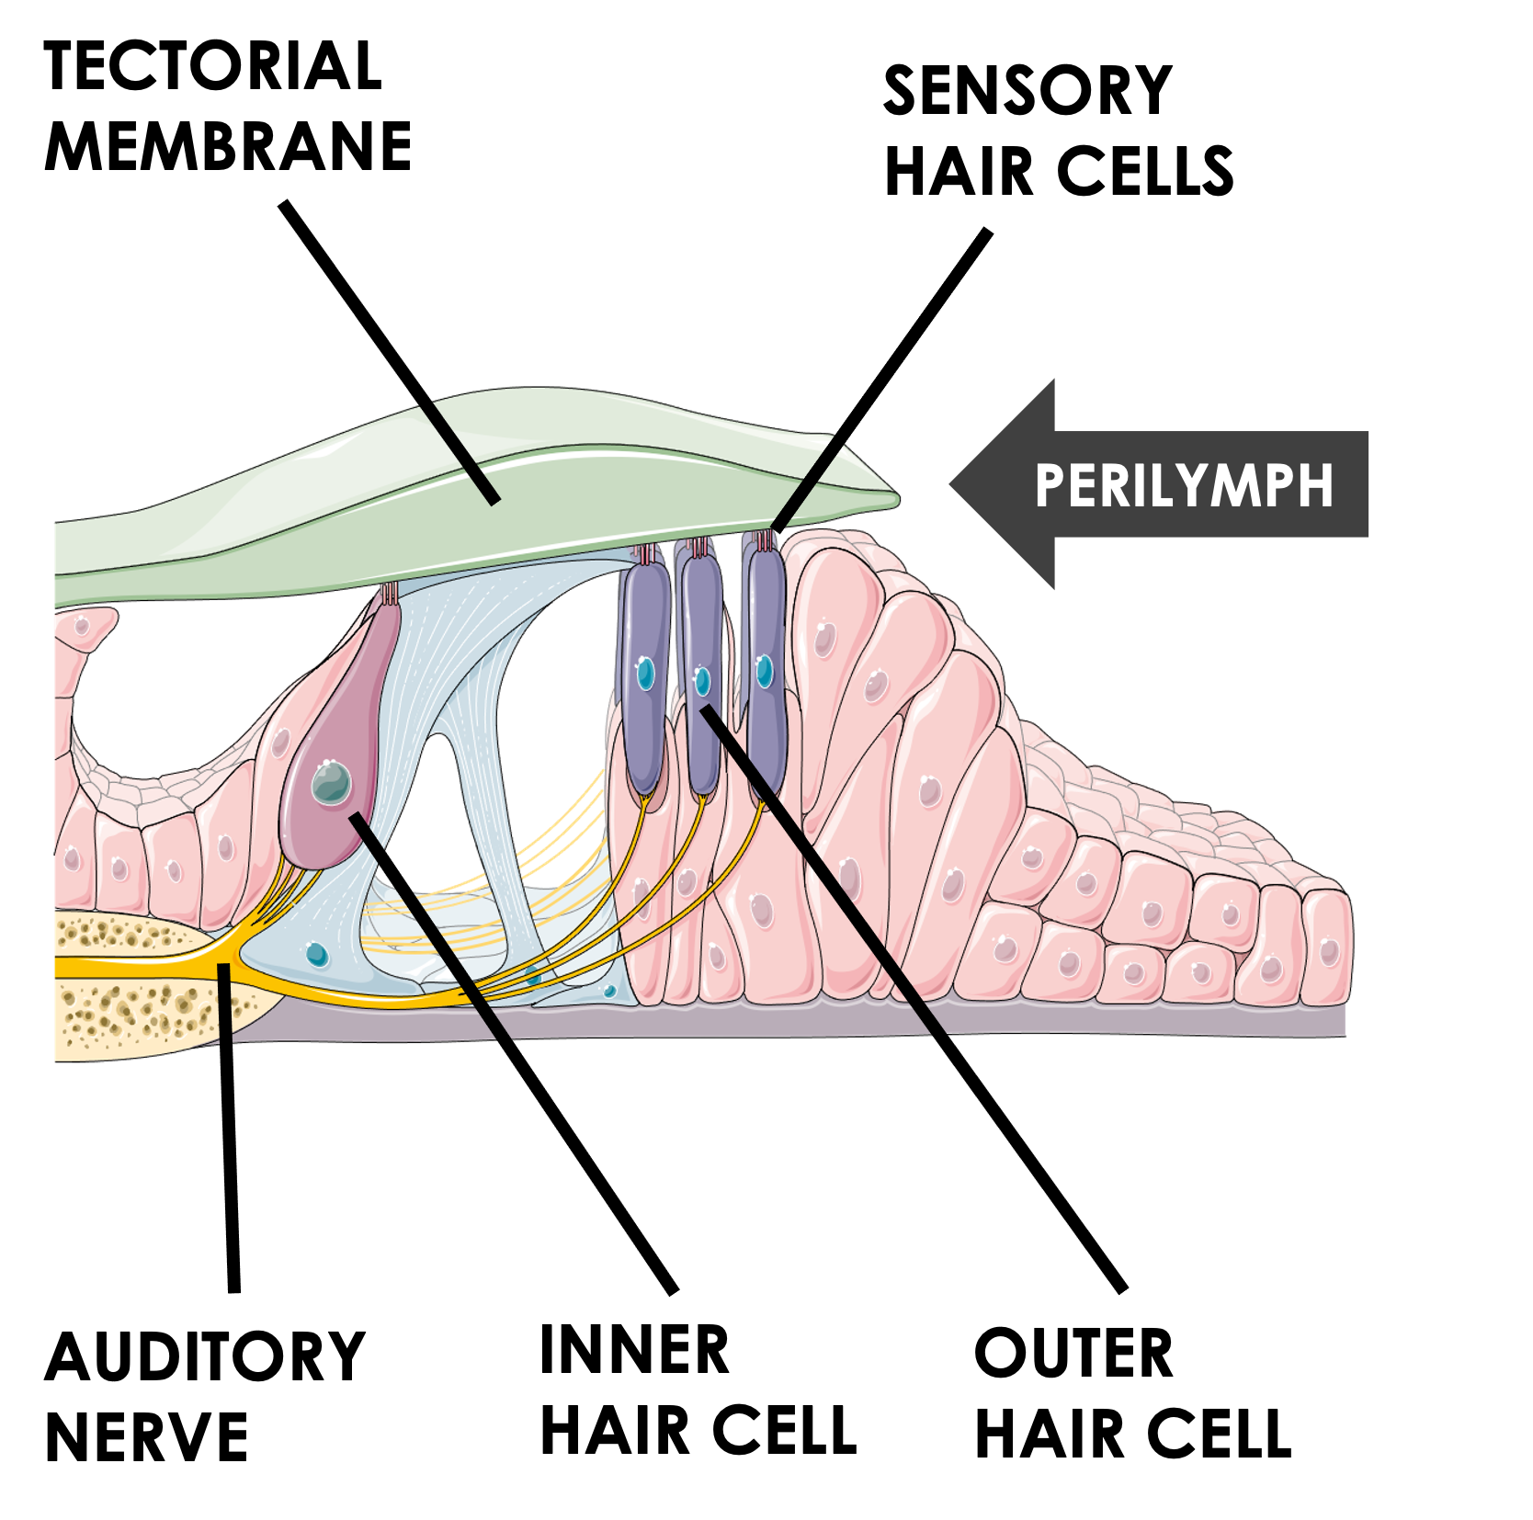
Arranged at key points within the cochlea are orderly rows of sensory hair cells, which are extensions of the auditory nerve, also called the vestibulocochlear nerve. Together with support cells and specialized membranes, the hair cells form specialized sensory structures called the organ of Corti, whose main job is to convert pressure waves in the perilymph into nerve impulses. Each organ of Corti contains bundles of hair cells that project into the tectorial membrane, a gel-like layer made of collagen and glycoproteins. When pressure waves in the perilymph of the cochlea cause the perilymph to move, the tectorial membrane moves as well, similar to seagrass swaying in an ocean current.
Physiology of Hearing

The sense of hearing is the perception of vibrations made by an object that are transformed into sound waves. It involves mechanical vibrations being transformed into electrical impulses and sent to the brain.

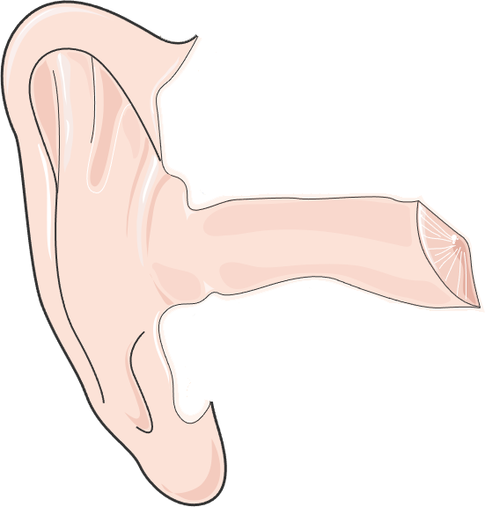
Step 1

At the outer ear, sound waves are gathered by the pinna, directed down the auditory canal, and strike the tympanic membrane (eardrum). The energy of the sound waves causes the tympanic membrane to vibrate, and the vibrations are transferred directly to the middle ear ossicles.

Step 2
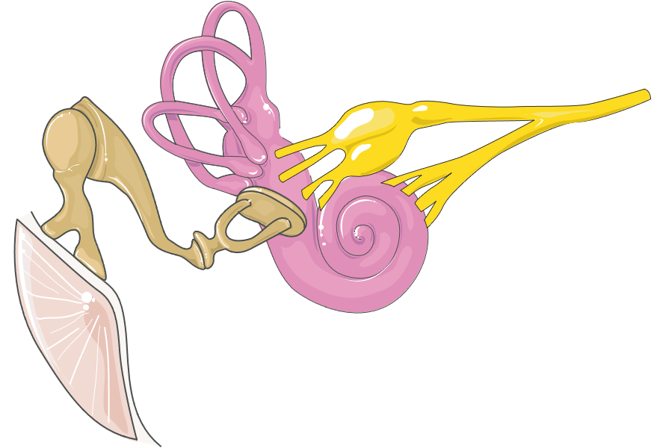
The malleus, incus, and stapes vibrate in sequence and amplify the vibrations from the tympanic membrane. The innermost stapes is connected to the cochlea at the oval window, a membrane at the opening of the inner ear. As the oval window vibrates, it creates pressure waves in the fluid perilymph of the cochlea.

Step 3

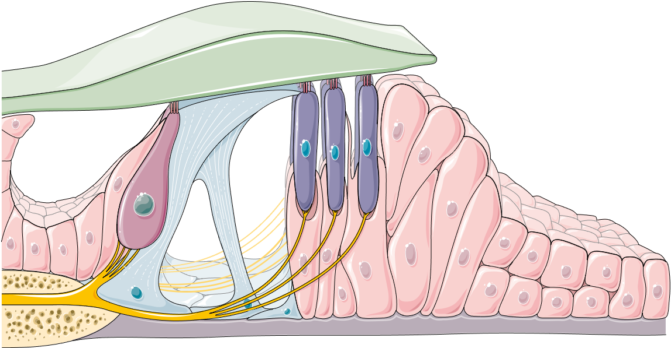
The pressure waves in the perilymph are transmitted to the organ of Corti within the cochlea. The changes in pressure cause the tectorial membrane to move. This movement is detected by the hair cells found just beneath it, which convert the mechanical motion to nerve impulses. The impulses travel along the along the cochlear branch of the vestibulocochlear nerve to the temporal lobe of the cerebrum, where the auditory cortex interprets the pattern of nerve impulses as sound.

Interpretation of Sound

In physics, sound consists of vibrations produced by an object that moves as a mechanical wave through a medium such as air. In physiology, sound is the perception of acoustic waves by the brain. Sound waves have three major characteristics: pitch, volume, and timbre.
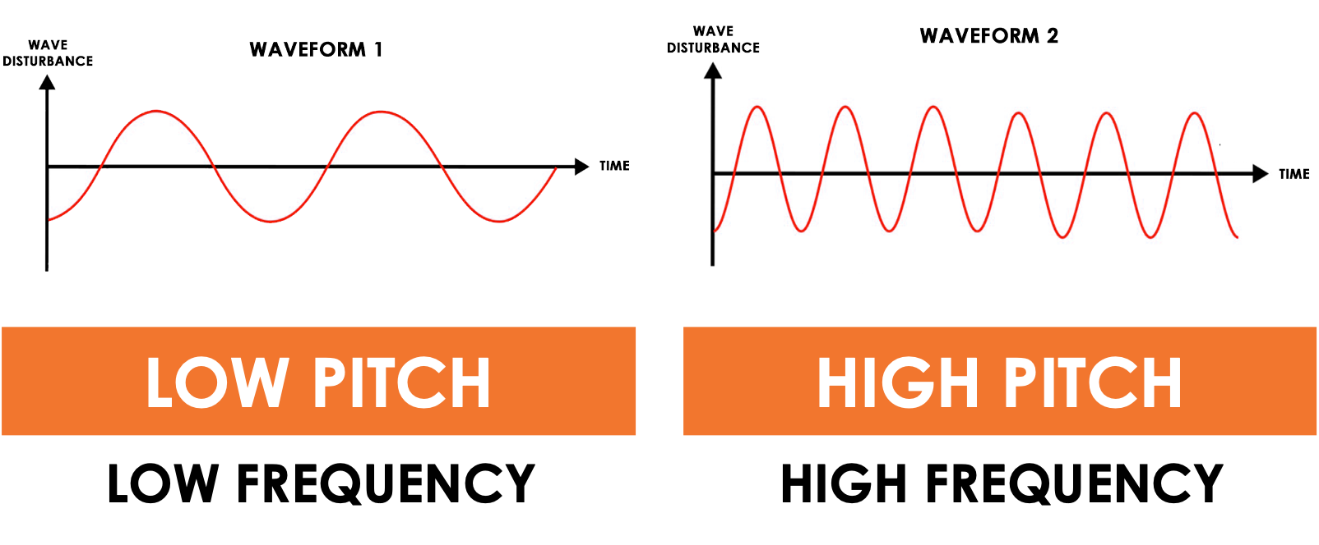
Pitch (frequency) is the number of vibrations per unit of time and is usually measured in Hertz (Hz). Higher frequency sound waves result in higher pitch sounds, such as a note played by a flute, while lower frequency sound waves result in lower pitch sounds, such as note played by a cello.

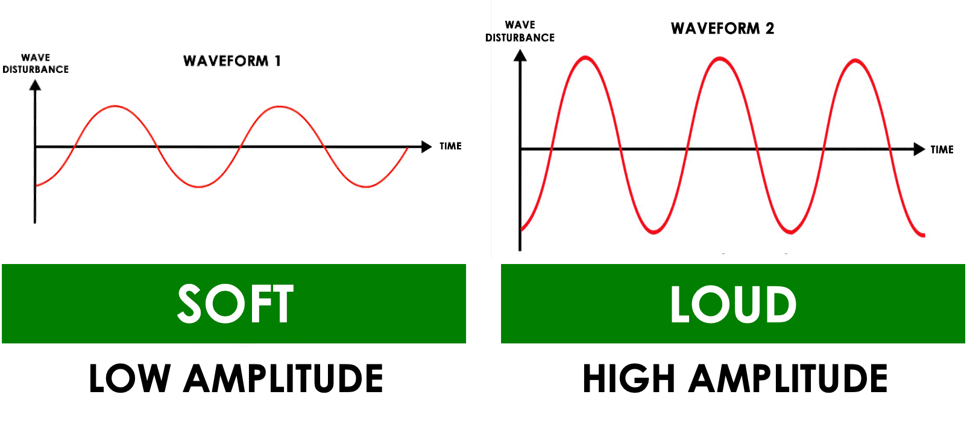
Intensity (volume) is the height or amplitude of the sound wave and is usually measured in decibels (dB). Higher amplitude sound waves result in louder sounds, such as those from a car horn, while lower amplitude sound waves result in softer sounds, such as a human whisper.

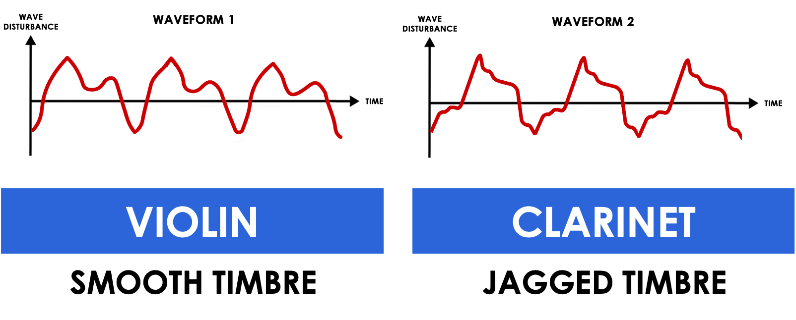
Timbre (quality) is the unique pattern or “texture” of a sound wave. Timbre is what makes a particular musical instrument or human voice have a distinctive sound. For example, a single note played on a violin will sound different than the same note played on a clarinet.

REVIEW: THE EAR – STRUCTURE AND FUNCTION

- Examine the diagram of the ear and write the name for each labeled part.

Anatomy of the Ear
A. |  | 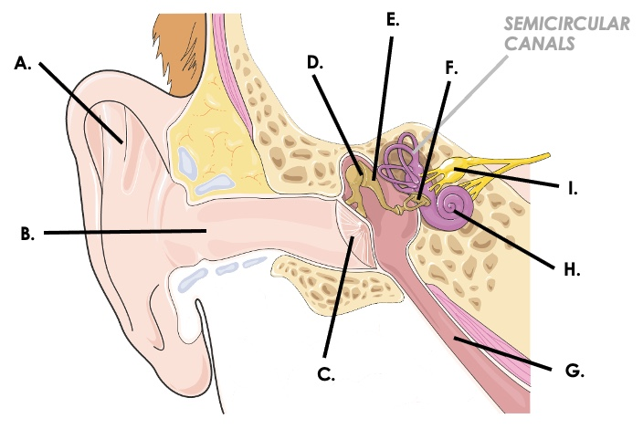
B.
C.
D.
E.
F.
G.
H.
I.

- There are 3 regions of the ear. For each, provide the name and list the main parts found in it.

3 Main Areas of the Ear
Ear Area |  | middle ear
Main Organs |  |  | cochlea, semicircular canals, auditory nerve

- Match each component of the ear listed with the correct description.

Ear Component |  |  | Description
 | pinna | A. | Nerve that transmits electrical impulses from the cochlea to the cerebrum
 | ear canal | B. | Tiny bones that transmit vibrations of the tympanic membrane to the inner ear
 | tympanic membrane | C. | Snail-shaped, fluid-filled cavity within the inner ear lined with sensory hair cells
 | ossicles | D. | A narrow tunnel that conducts sound waves from the environment to the tympanic membrane
 | cochlea | E. | Region of the brain region that processes patterns of nerve impulses as sound
 | auditory cortex | F. | Shell-shaped structure that directs sound waves into the auditory canal
 | vestibulocochlear nerve | G. | Thin membrane at end of auditory canal that vibrates after being struck by sound waves

- Fill in the blanks below to describe each step of hearing in detail.

Steps to Hearing
1 | - Sound waves are gathered and focused into the auditory canal by the _______________  - Auditory canal is lined with _______________ glands that secrete protective wax  - Energy of sound waves cause _____________________ to vibrate
2 | - Three bones: __________, __________, and __________ amplify the vibrations  - Bones transmit the vibrations to inner ear at a membrane called the _______________  - As it vibrates, pressure waves are formed in the fluid _______________ in the cochlea
3 | - Pressure waves in perilymph are transmitted to the organ of _______________  - Movement of the tectorial membrane stimulates _______________ found below it  - Impulses travel along the _____________________ nerve to the _______________ cortex

- Sound waves have 3 properties. Describe each property in the summary table below.

3 Properties of Sound Waves
Pitch | Intensity | Timbre

- Examine the sound waves shown below. Identify what wave property is different between the two waveforms and describe how the waves would sound different from each other.

A. | 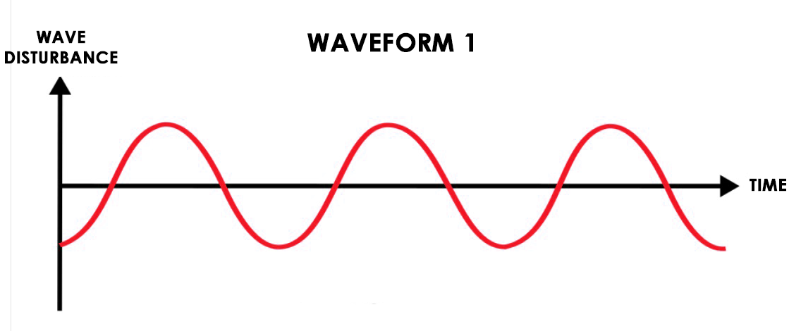 | B. | 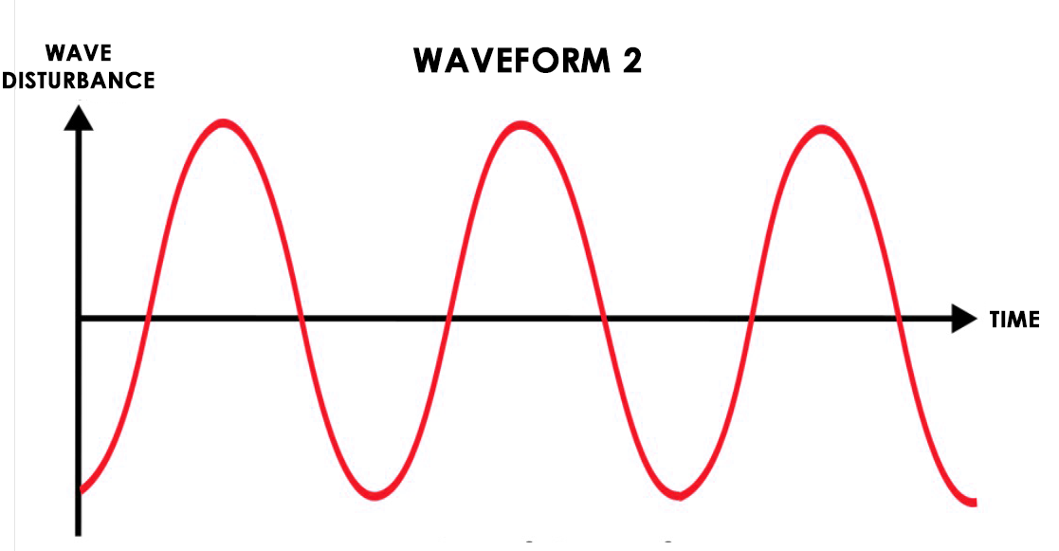

- Examine the sound waves shown below. Identify what wave property is different between the two waveforms and describe how the waves would sound different from each other.

A. |  | B. | 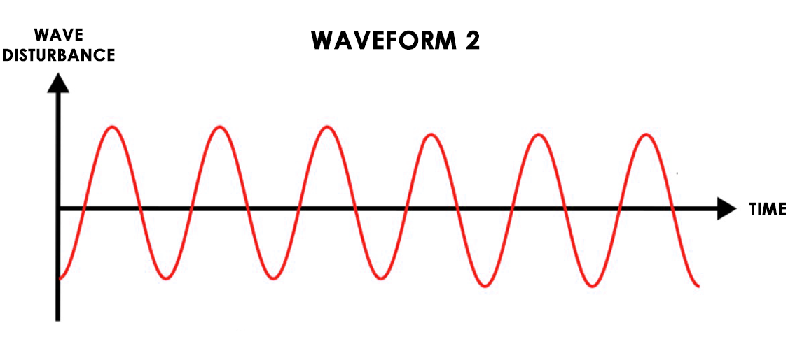

REVIEW: THE EAR – STRUCTURE AND FUNCTION (KEY)

- Examine the diagram of the ear and write the name for each labeled part.

Anatomy of the Ear
A. | pinna (or auricle)
B. | auditory canal
C. | tympanic membrane (or eardrum)
D. | malleus (or hammer)
E. | incus (or anvil)
F. | stapes (or stirrup)
G. | auditory tube (or Eustachian tube)
H. | cochlea
I. | vestibulocochlear nerve (or auditory)

- There are 3 regions of the ear. For each, provide the name and list the main parts found in it.

3 Main Areas of the Ear
Ear Area | inner ear | middle ear | outer ear
Main Organs | pinna, ear canal, tympanic membrane | malleus, incus, stapes, auditory tube | cochlea, semicircular canals, auditory nerve

- Match each component of the ear listed with the correct description.

Ear Component |  |  | Description
F | pinna | A. | Nerve that transmits electrical impulses from the cochlea to the cerebrum
D | ear canal | B. | Tiny bones that transmit vibrations of the tympanic membrane to the inner ear
G | tympanic membrane | C. | Snail-shaped, fluid-filled cavity within the inner ear lined with sensory hair cells
B | ossicles | D. | A narrow tunnel that conducts sound waves from the environment to the tympanic membrane
C | cochlea | E. | Region of the brain region that processes patterns of nerve impulses as sound
E | auditory cortex | F. | Shell-shaped structure that directs sound waves into the auditory canal
A | vestibulocochlear nerve | G. | Thin membrane at end of auditory canal that vibrates after being struck by sound waves

- Fill in the blanks below to describe each step of hearing in detail.

Steps to Hearing
1 | - Sound waves are gathered and focused into the auditory canal by the pinna  - Auditory canal is lined with ceruminous glands that secrete protective wax  - Energy of sound waves cause tympanic membrane to vibrate
2 | - Three bones: malleus, incus, and stapes, amplify the vibrations  - Bones transmit the vibrations to inner ear at a membrane called the oval window  - As it vibrates, pressure waves are formed in the fluid perilymph in the cochlea
3 | - Pressure waves in perilymph are transmitted to the organ of Corti  - Movement of the tectorial membrane stimulates hair cells found below it  - Impulses travel along the vestibulocochlear nerve to the auditory cortex

- Sound waves have 3 properties. Describe each property in the summary table below.

3 Properties of Sound Waves
Pitch | Intensity | Timbre
The frequency or number of vibrations per second | The amplitude or height of a sound wave | The quality or unique pattern of a sound wave

- Examine the sound waves shown below. Identify what wave property is different between the two waveforms and describe how the waves would sound different from each other.

A. |  | B.
- The two sound waves differ in amplitude or loudness. (They have the same frequency)
- Waveform 1 would be softer while waveform 2 would be louder.

- Examine the sound waves shown below. Identify what wave property is different between the two waveforms and describe how the waves would sound different from each other.

A. |  | B.
- The two sound waves differ in frequency or pitch. (They have the same amplitude)
- Waveform 1 would be lower in pitch while waveform 2 would higher in pitch.

