Microscope skills

- Handle the slides correctly and load them into the microscopes
- Familiarise yourself with the parts of a microscope

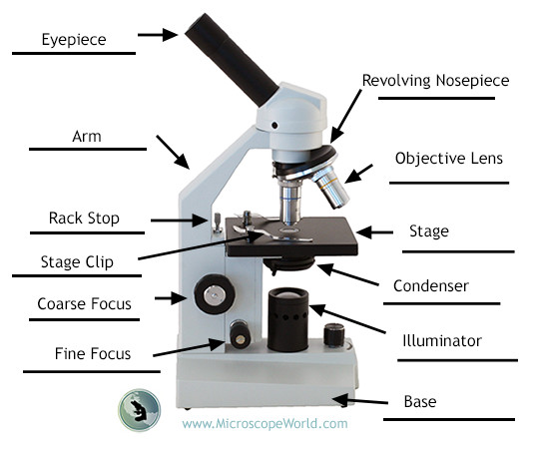
- Using low power magnification, focus the microscope on a slide using the coarse and fine focus, at an appropriate lighting and angle to view the specimen.

Wild Animal

- All Wild animals may be viewed from a safe distance
- Some wild animals may be handled. Specific knowledge is required in the handling of all wild animals
- DO NOT FEAR, DO NOT FRIGHTEN DO NOT FLEE a wild animal, unless it is charging you. Back away without making unnecessary noise.

Animal | General guidelines
Insects | Walking, Use a piece of paper and let it climb onto it  Flying Stay still it should fly around you  Jumping Stand behind it animals rarely jump backwards  Don´t handle insects, let them handle you.  Check for biting mouthparts and stings before handling
Frogs / Toads | Jump. Coax them with a small cardboard box if you have to move them. Do not attempt to touch brightly colored frogs or toads
Snakes | Unless you recognise a snake, assume it is venomous and simply avoid it by walking away calmly
Lizards | Many small lizards can be handled but this should be done with care as they are fragile. Geckos are an example. Do not attempt to handle a lizard you do not recognise, or any lizard larger than 10cm.
Larger mammals | Do not ever attempt to feed or touch a wild mammal. Simply enjoy viewing it from a safe distance.A safe distance is mostly simply defined as one where the animal does not respond to your presence.

You will be shown some cards with images of wild animals. Role- play the correct response to encountering a wild animal represented by that card.

Measuring liquids in biology

- Try to measure the amount of water in the beaker (this is not easy, why?)
- Select a syringe and transfer the liquid to a measuring cylinder. (can the syringe help you measure the liquid?)
- Use the measuring cylinder to get an accurate measurement of the volume of liquid
- What is the difference between your answer to 1 and 4. Regarding the measurement of the volume of liquid. Use either the word accurate, precise, or reliable in your answer.
- Take the dropper, and see how many drops of water you can balance on a penny before the water overflows. Each drop has a volume of 0.5ml, calculate the volume of this water.

Drawing line graphs and scatter plots

- Using the hand dynamometer and data logger, measure the maximum force exerted by the right hand of each of your group.
- Plot this information against your age in months on graph paper
- Discuss which kind of plot is better using the information below to draw this graph.
- Sketch a graph of your groups data.
Line graph - shows definite values at even intervals. Scatter plot shows relationships between variables.

